
(An Autonomous Institution, Affiliated to Anna University, Chennai)
MINI PROJECT
CRCIKET WORLD CUP PERFORMANCE AND VISUALIZATION USING PYTHON, POWER BI, AND TABLEAU
Framework for Data Visual Analytics

VARSHINI A

241501238
ABSTRACT
This mini project, carried out for the subject Framework of Data Visualization and Analytics (FDVA), analyses a Cricket World Cup (CWC) match dataset using Python, Microsoft Power BI and Tableau. The dataset contains cricket match statistics, including teams, players, runs scored, wickets taken, overs played, match results, venues and player performances. Python with Pandas was used to clean the data, handle missing values, standardize team and player names, and prepare the dataset for analysis. Matplotlib and Seaborn were used to create visualizations such as team-wise performance, player statistics, runs scored, wickets taken and match result comparisons. Interactive dashboards were developed in Power BI and Tableau using filters, KPI cards and charts to explore team performance, player contributions and match outcomes. The analysis helps identify top-performing teams and players, compare batting and bowling performances, and understand match trends throughout the Cricket World Cup. The project demonstrates how data preprocessing, visualization and interactive dashboards can transform cricket statistics into meaningful insights for sports analysis and performance evaluation.
.

1. Data Preprocessing
The dataset cwc.csv has 48 rows and 44 columns. It was cleaned in Python using Pandas, as shown below.

Loading and inspecting the data

df = pd.read_csv("CWC2023.csv")
df.shape # (48, 44)
df.info()
Match Date and Match Time were stored as text and converted to appropriate date/time formats. Runrate B was converted to numeric format for accurate cricket analysis.

Missing values and duplicates

print(df.isnull().sum())
print("Duplicate rows:", df.duplicated().sum())
Missing values were checked in cricket match data, and duplicate rows were verified. No duplicate rows were found (0).

Fixing data types and filling missing values

df['Runrate B'] = pd.to_numeric(df['Runrate B'], errors='coerce')
df['Runrate B'] = df['Runrate B'].fillna(df['Runrate B'].median())
Same steps for other numerical columns
In the CWC Match Analysis dataset, inconsistent team and player names were standardized, numeric columns such as runs, wickets and overs were converted to appropriate data types, and missing values were handled using suitable methods. After preprocessing, the dataset was checked to ensure data consistency and to identify any remaining missing values.

Standardising text values

df['Team'] = df['Team'].astype(str).str.strip().str.upper()
df['Opponent'] = df['Opponent'].astype(str).str.strip().str.upper()
df['Player'] = df['Player'].astype(str).str.strip().str.title()
df['Runs'] = pd.to_numeric(df['Runs'], errors='coerce')
df['Wickets'] = pd.to_numeric(df['Wickets'], errors='coerce')
df['Overs'] = pd.to_numeric(df['Overs'], errors='coerce')
df['Venue'] = df['Venue'].astype(str).str.strip().str.title()
df['Match_Result'] = df['Match_Result'].astype(str).str.strip().str.upper()
Inconsistent values in team names, player names, match results, venues and other categorical columns were standardized into a consistent format. Numeric columns such as runs, wickets, overs and scores were cleaned and converted to appropriate numeric data types. Missing or invalid values were handled to improve data consistency and prepare the dataset for visualization and analysis.

Converting the Match date

df['Date'] = pd.to_datetime(
df_original['Date'].astype(str).str.strip(),
format='mixed',
dayfirst=True,
errors='coerce')
df['Match_Year'] = df['Date'].dt.year
df['Match_Month_Name'] = df['Date'].dt.month_name()

The initial date conversion was checked for missing values. The original date column was parsed again using format='mixed' to handle different date formats. The remaining missing dates were checked to ensure the data was ready for Cricket World Cup match analysis.

CREATING NEW COLUMNS AND EXPORTING THE DATASET

df['Match_Year'] = df['Date'].dt.year
df['Match_Month'] = df['Date'].dt.month
df['Match_Month_Name'] = df['Date'].dt.month_name()
df.to_csv("Cleaned_CWC_Matches.csv", index=False)
print("Dataset Shape:", df.shape)
print("Cleaned dataset exported successfully.")

New columns such as Match_Year, Match_Month and Match_Month_Name were created from the match date to support year-wise and month-wise analysis. The cleaned Cricket World Cup dataset was exported as Cleaned_CWC_Matches.csv and used for generating visualizations and developing interactive dashboards in Power BI and Tableau. The final dataset dimensions were verified after export.

2. Data Visualization Using Python
Eight charts were created from the cleaned CWC 2023 dataset using Pandas, Matplotlib and Seaborn to analyze team performance, player awards, match trends and cricket statistics.
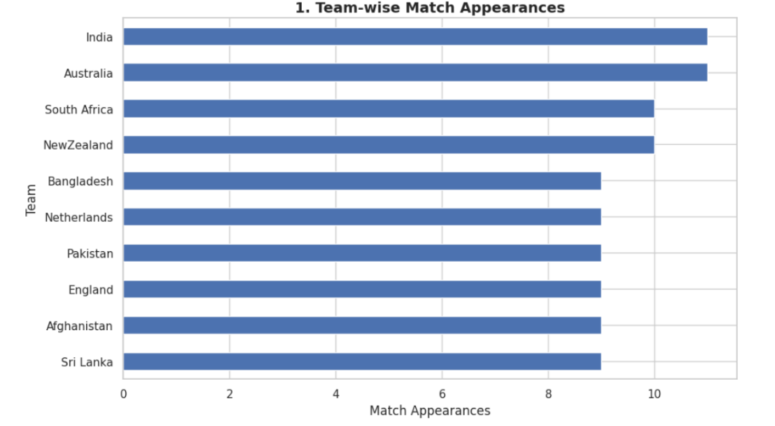
Figure 2.1:Team wise match appearances(bar graph)
Result: India and Australia played the most matches (11 each), followed by South Africa and New Zealand (10 each), while the remaining six teams played 9 matches each.
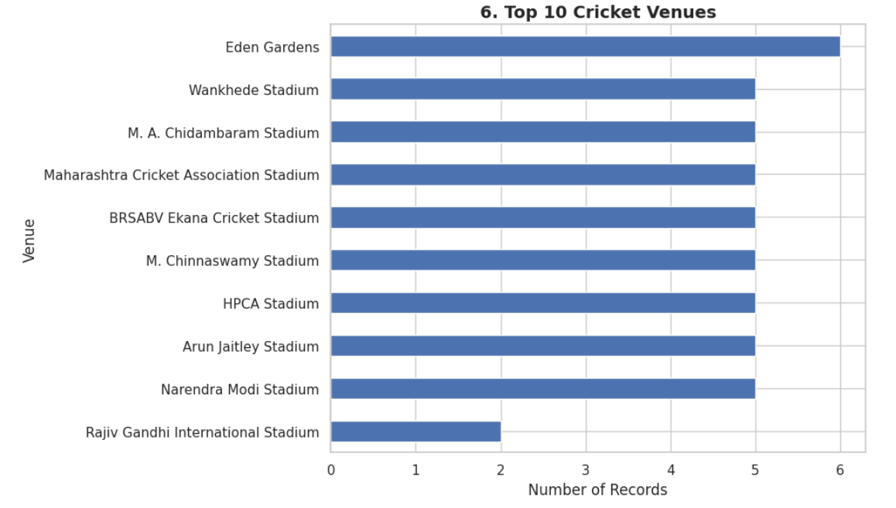
Figure 2.2: Top 10 cricket venues(bar chart)
Result: Eden Gardens has the highest number of records (6), followed by eight venues with 5 records each, while Rajiv Gandhi International Stadium has the lowest (2).
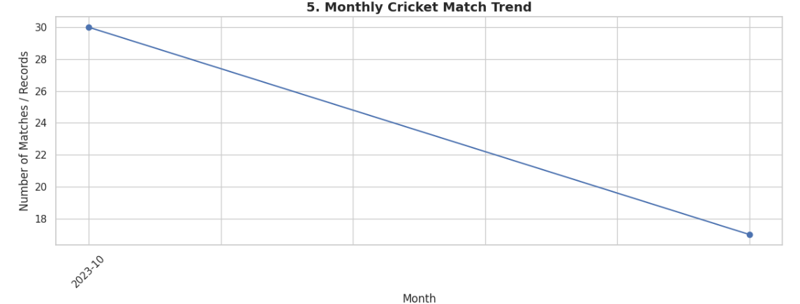
Figure 2.3: Monthly Cricket match trend(line graph)
Result: Cricket match records decreased from 30 in October 2023 to 17 in the following month, showing a declining trend.
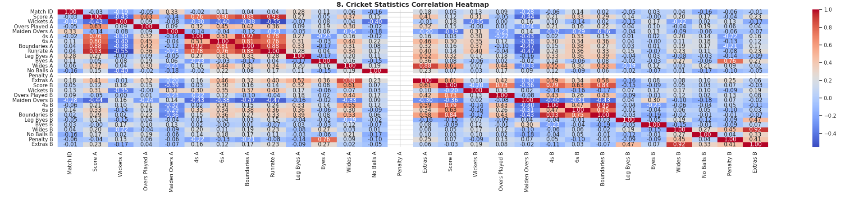
Figure 2.4: Cricket Statistics (Heat map)
Result: The correlation heatmap shows strong positive correlations between cricket statistics such as score, boundaries, and run rate, while blue cells indicate negative correlations between certain variables.
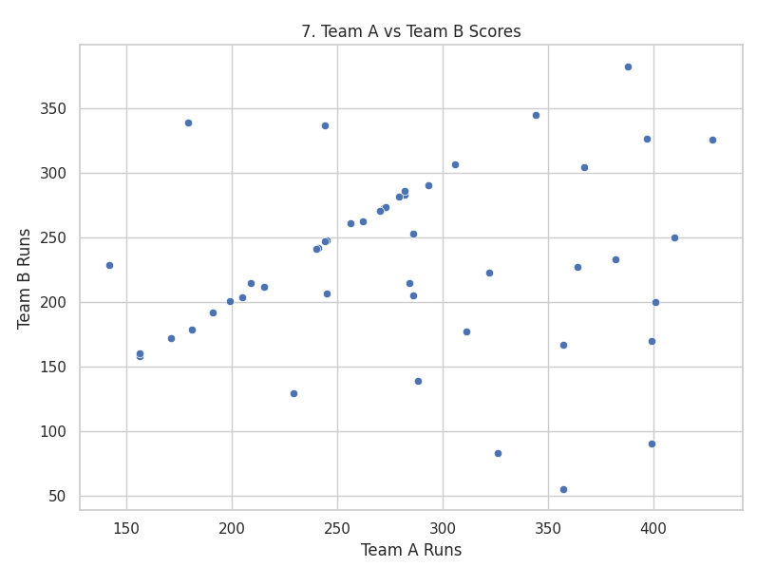
Figure 2.5: Team A vs Team B scores
Result: The scatter plot shows a generally positive relationship between Team A and Team B scores, but the points are widely scattered, indicating variations in team performance
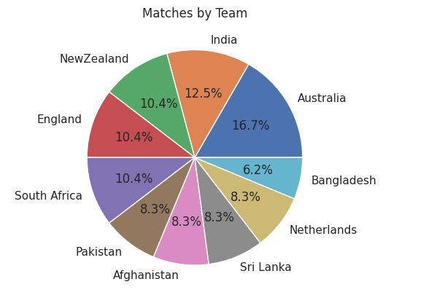
Figure 2.6:Matches by Teams(Pie Chart)
Result: The pie chart shows that Australia has the highest share of matches (16.7%), followed by India (12.5%), while Bangladesh has the lowest share (6.2%).
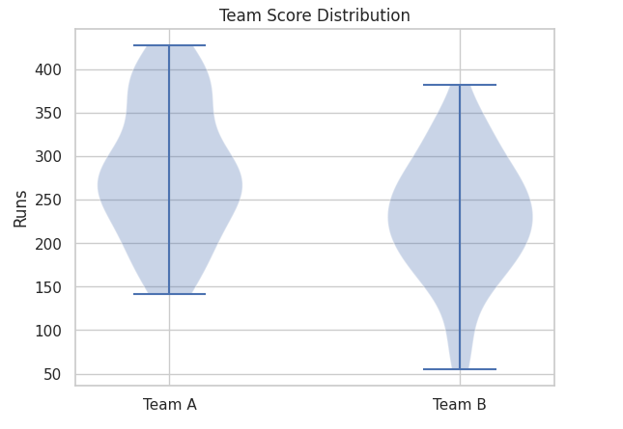
Figure 2.7:Team Score Distribution (violin plot)
Result: The violin plot shows that Team A generally scores higher than Team B, with Team A reaching around 425 runs and Team B around 380 runs.
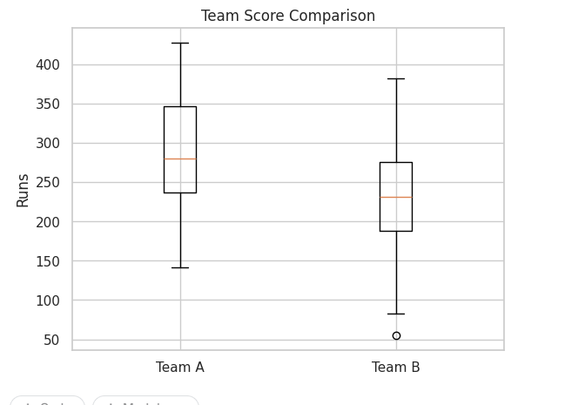
Figure 2.8: Box Plot to compare scores
Result: The box plot shows that Team A has a higher median score (around 280 runs) than Team B (around 230 runs), while Team B has one low-score outlier.
The overall analysis shows that Australia has the highest share of matches, Team A generally scores higher than Team B, and the charts reveal variations in team scores, match appearances, venue records, and correlations among cricket statistics.

3. Power BI Dashboard
Power BI was used to build a one-page interactive dashboard from the cleaned cricket worldcup data.
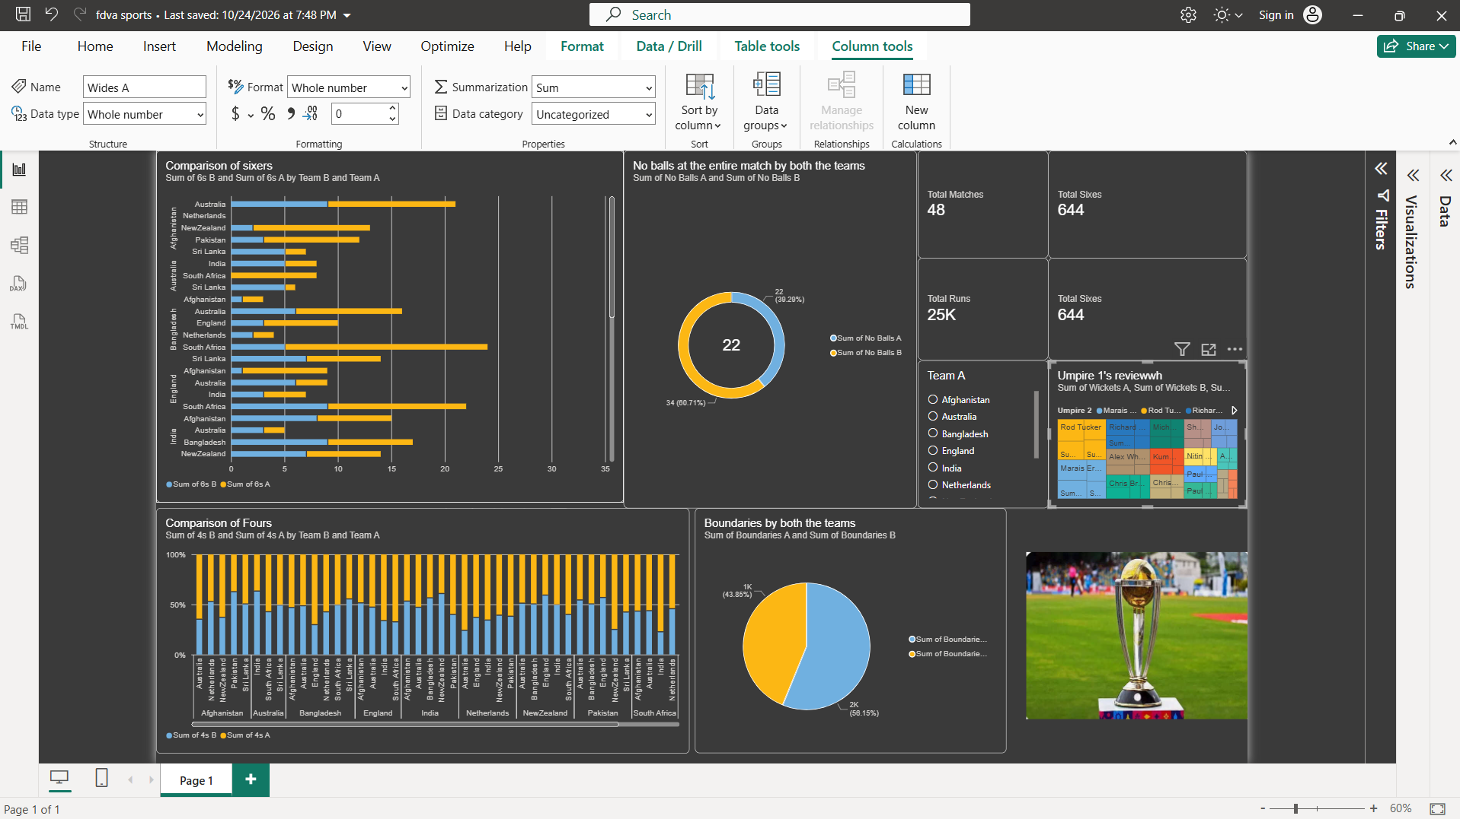
Figure 3.1: Cricket World Cup Dashboard in Power BI
- Slicers: Team Slicer filters the dashboard by team
- KPI cards: Total Matches = 48, Total Runs = 25K, Total Sixes = 644, and Total Sixes = 644 (duplicate card; replace the last one with Total Fours).
- Charts: Comparison of sixes by team, no-balls comparison using a doughnut chart, comparison of fours using a 100% stacked column chart, boundaries comparison using a pie chart, and an umpire review treemap.
- Insights: The dataset contains 48 matches and approximately 25K total runs. The sixes comparison highlights differences between teams, while the boundary chart shows one team contributing approximately 56.15% and the other 43.85%.

4. Tableau Dashboard
Tableau was used to build the “Cricket World Cup 2023 Performance Dashboard” from the same cleaned data.
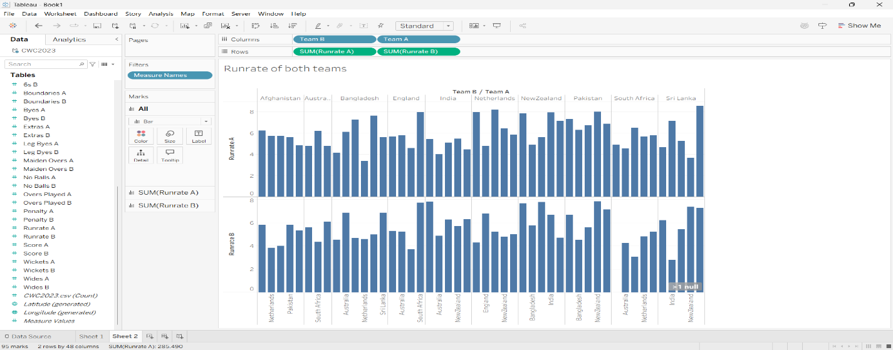
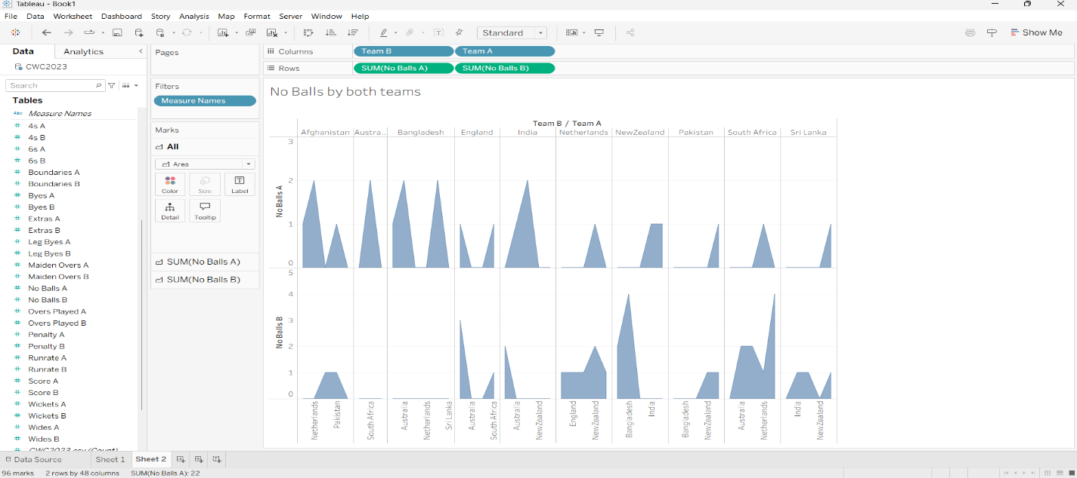
Figure 4.1: Cricket World Cup Dashboard in Tableau
- No-Balls Comparison: Team B recorded more no-balls overall than Team A, with 34 compared to 22.
- Run Rate Comparison: Team A and Team B show varying run rates across matches, with several values reaching around 8 runs per over.
- Team Performance: Australia, India, and South Africa show noticeable variations in run rates between the two teams.
- Insights: The charts highlight differences in bowling discipline and scoring speed, helping compare team performance across the 2023 Cricket World Cup.

